**Warm winter crop boon**

The rabi crop harvest may be better with seeds germinating faster in this year's warmer winter, Birsa Agricultural University (BAU) weather scientist and chairman of agricultural physics and meteorology A. Wadood said.

By RUDRA BISWAS in Ranchi

* Published 9.12.16

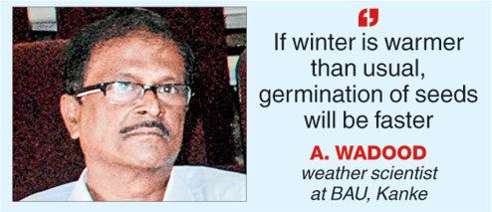

**Ranchi, Dec. 8:** The rabi crop harvest may be better with seeds germinating faster in this year's warmer winter, Birsa Agricultural University (BAU) weather scientist and chairman of agricultural physics and meteorology A. Wadood said.

"Maximum temperatures continue to hover around 27°C and 28°C, which are on the higher side for December in Jharkhand. Day temperatures should normally be around 22°C. But, we are advising farmers there is no cause for worry," Wadood said.

Explaining why, he said: "If winter is warmer than usual, germination of seeds will be faster, raising prospects of better rabi crop yield. Cold winters delay seed germination."

In Jharkhand, rabi crop sowing begins after December 15 and is harvested in April.

Wadood's only concern was that Jharkhand hadn't received rainfall in the past two months.

"There is no moisture in soil. Those farming rabi crops like wheat, mustard, white chickpea ( *kabuli chana*), green chickpea (green chana) coriander ( *dhania*) need irrigated fields before sowing. Even in previous years, there was some November rain. This year is an exception," he said.

But, he also pointed out that every year Jharkhand gets rains in December and January due to Northwest westerlies that bring heavy snowfall in Kashmir, Himachal and the northern regions.

"So far, there is no indication that it (rain) won't happen. But if it doesn't rain, farmers would have to use up their stored water in dobas, ponds and wells to irrigate their fields before sowing rabi crops," he said.

Cautioning that global warming was everywhere, and Jharkhand was no exception, Wadood said a warmer-than-usual winter was its direct fallout.

"This has been an unusual year for Jharkhand with summer temperature rising to 46-48°C, rapid fall in groundwater table and an acute drinking water crisis. If farmers are forced to use up stored water to irrigate rabi crops, it might not augur well for the next kharif crop unless it rains abundantly in 2017 to make up for the loss," he warned.